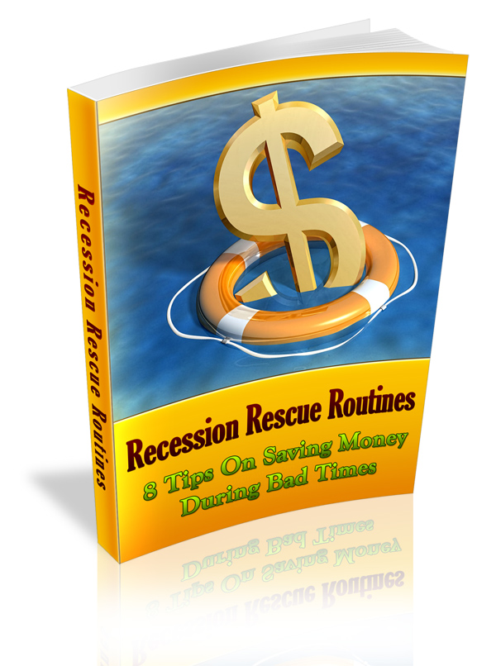

Terms and Conditions

LEGAL NOTICE

The Publisher has strived to be as accurate and complete as possible in the creation of this report, notwithstanding the fact that he does not warrant or represent at any time that the contents within are accurate due to the rapidly changing nature of the Internet.

While all attempts have been made to verify information provided in this publication, the Publisher assumes no responsibility for errors, omissions, or contrary interpretation of the subject matter herein. Any perceived slights of specific persons, peoples, or organizations are unintentional.

In practical advice books, like anything else in life, there are no guarantees of income made. Readers are cautioned to reply on their own judgment about their individual circumstances to act accordingly.

This book is not intended for use as a source of legal, business, accounting or financial advice. All readers are advised to seek services of competent professionals in legal, business, accounting and finance fields.

You are encouraged to print this book for easy reading.

Table Of Contents

Foreword

Chapter 1:
About Our Times

Chapter 2:
Ensure Your Small Business

Chapter 3:
Saving Money On Fuel

Chapter 4:
Produce A Budget

Chapter 5:
If You Have To Sell Your House-Do It Yourself

Chapter 6:
Save On The Light Bill

Chapter 7:
Saving Money On Groceries

Chapter 8:
Save On Fun Time

Chapter 9:
Saving Money On Taxes

Foreword

Times are goon. The securities market has been having bad weeks for a long time and now is the time to make certain that you come through the harsh years bound to be in front. Attempt to keep your job or make the most out of your home business.

Attempt not to lose your home. I Understand that like everybody I’ve been trimming down substantially recently for our loved ones. This book will pass along ways that you may prefer to think about saving money in this foul economical climate.

Recession Rescue Routines

8 Tips On Saving Money During Bad Times

Chapter 1:
About Our Times

Synopsis

It is more important today than ever to keep a close eye on your money. Our economic times are hard and we have to do all we can do to cut expenses… I will show you how!

Evaluating Our Times

Are you like many of us, concerning yourself about the economic system, sky skyrocketing fuel prices and the cost of just living? Regrettably, these are matters that we have to consider nowadays. Over the preceding year, particularly, we have experienced the prices of day-to-day items skyrocket. Read on for a few helpful tips that can assist you in learning to save income. They're amazingly easy. We can easily miss them; but they may have a huge affect on our budget.
In this time of economical adversity, we need to be motivated to make the most of what we have acquired.
The current universal recession has seen a lot of people finding it difficult to preserve their lush life-styles. To a few individuals it's become even hard to fulfill their day-to-day necessities. Matters that earlier were needs have now gotten to be wants since they're no more affordable and somebody has no alternative but to live without them, all ascribable to the economical recession.
It's consequently become imperative for individuals to discover ways to pass through from this lush lifestyle smoothly in order, to the lowest degree, meet the primary essentials of life. It may prove to be rather a project particularly where youngsters are affected, they might not comprehend why matters have changed drastically therefore as a parent you need to explain to them precisely what is coming about.

A point to look at would be, if you used to go to the local movie theater for movies every now and then, you are able to choose to go to the video store and choose some up to date movies, whip up a few snacks to crunch on as you view the movies in the house. As for those who previously go for extended holidays as international tourist However now they can't afford to do the same, they may decide to be local tourist.
If you can't afford to buy something at present, instead of straining yourself it might be advisable to begin saving for it. The additional matter to avoid is acquiring a charge card that you can't afford to pay for. Charge cards are a venomous circle where if you're not heedful you'll be just paying the interest therefore it can destroy your monetary resources. Consequently, prevent the use of charge plates and purchase just what you are able to afford for today as you wait for the economic system and your financial condition to stabilize.
Everybody can use a bit of additional room in their budget. You might be worried about climbing gas prices and its result on the price of your groceries and so forth. Well, never fear as I’m here are some techniques that you are able to do today to help you save as well as make some money in these hard times.

Chapter 2:
Ensure Your Small Business

Synopsis

Aren't you just anxious for a bail-out like the banking companies? In times of recession, small business proprietors are the ones that get struck hard the most.
Protect Your Small Business

Regrettably for you, you're not AIG and you're not qualified for a ceaseless line of life from the United States. If a company of that magnitude came down, it will for certain be felt around the globe. However you? You're just a little business owner and you're, in every feel of the word, little. Don't be concerned however. It's possible to outride this recession with your business still in good shape. Read on for additional info.

Hint # 1: Observe what you're paying out.
At present, to a higher degree than ever, is the time for you to scrutinize your expenditures. And that's from your bond paper to your public utility accounts. How much are they costing you per calendar month? Are you returning any waste by allowing for the lights to be left on? Are you keeping up your equipment correctly avoiding crazily big repair expenditures?

Hint # 2: Reduce your expenditures.
After observing of your expenditures, you have to cut back on them. You need to scrutinize for your small business costs is to discover where you are able to save up. If you're outlay a bit much on tissue paper, cut back on usage. Be watchful. Perpetually seek directions to bring down costs and to optimize. You'd be amazed at how small deletions bestow huge savings.

Hint #3: Let go employees only you have to.
Wages absorb a chunk of small business expenditures, However keep in mind that it will cost you a great deal more if you do everything yourself. What's more is the reality that it might be damaging to your small business if you substitute existing employees with naïve new hires. I know of a real estate assessment company, who didn't mind their talent and son, they're suffering at present. Knowledgeable employees are by nature more expensive. However don't forget that they're also more effective. If you are sailing fierce seas because of the economic system, keep your employees in the loop! They'd value it. They might even go the additional mile for you. Remember, no one prefers to turn a loss on their job in this economic system either.

Hint #4: Let go clients who are not worth it.
Oh thigh-slapper. I can't begin discussing this and not just continue on and on and on. There are simply merely customers who are not worth maintaining. They're normally the ones who bargain for the bottom price but are the hardest. Since I'm in the service industry, I just merely jack up my cost to fire them. And I cite the sort of service that they require as the reason for the fresh price. Don't let your customers to step all over you just because it's a recession. Time is as well income. And time exhausted on customers who are overly difficult might be better spent on promoting your small business to draw in the type of customers that you'd like to service.

Hint #5: Discover your niche.
Observe where the absolute majority of your business is faring from. Are they from old persons? Working mommies? If you discover your niche, it's easier to yield more business in that certain demographic. Over the long-run, you'll find that proceeding within your niche in reality makes you more fruitful for a lot less efforts.

Hint #6: Expand your promotion endeavors.
During hard times, the budget for promotion and advertising is frequently the first one to be trounced. No, nah, nay. Never do that. A recession is all the more cause that you should proceed in your promotion efforts for your small business. Individuals will still keep purchasing even during recession, and they're more likely to only purchase the brands they know. Where are your challengers now? Are they hiding out? Grab this chance to make yourself well-known. When the recession is all over, you'll find your small business leading the market.

Hint #7: Remain confident.
It's difficult to break a smile when everybody is busy whirling of fresh story of gloominess and doomsday because of the economic system. But stay confident, all right? If you want your small business to remain afloat, don't shape your mind to fail. Be pleased even during unsure times. Remember, a recession is simply a impermanent condition. If there's a break, there will also be a blast. While you're ready and waiting, keep yourself and your small business united by remaining confident despite everything.

Chapter 3:
Saving Money On Fuel

Synopsis

Whether you drive a two-seat crossbreed or a three-ton sport utility vehicle, chances are you are able to squeeze a little more distance out of each gallon of gas -- and at today's gas prices, an betterment of just one or two miles per gallon (MPG) can really tote up.

These fuel saving ideas have served me advantageously over the years, and they can help you better your car's fuel saving and take some of the sting out of high gas prices. Many of these tips will give you a very thin increase in MPG -- but use a lot together and the mileage betterments will really add up.

Save Some Gas

1. Ease Up
Among the better ways to save fuel is to plainly reduce your speed. As speed step-ups, gas economy lessens exponentially. If you're among the "ten-over on the expressway" set, attempt driving the speed limit for a couple of days. You'll save more fuel and your travel won't take much longer. (Just make sure you stay to the right, so you won't block the less-enlightened.)

2. Ascertain your tire pressure
Under-inflated tires are among the many commonly brushed off causes of cheesy MPG. Tires mislay air due to age and temperature ; under-inflated tires have more rolling impedance, which means you require burning more fuel to keep your car running. Purchase a dependable tire gauge and check your tires at least once a month. Make certain to check them when they're frigid, since driving the car warms the tires along with the air within them, which step-ups pressure and gives a incorrectly elevated reading. Utilize the inflation pressures shown in the owner's manual or on the information plate in the driver's doorpost.

3. Scope out your air cleaner
A dirty air cleaner confines the airflow into the engine, which damages performance and saving. Air cleaners are simple to check and alter; take out the filter and hold it up to the sun. If you can't see light breaking through it, you need a fresh one.

4. Speed up with caution
Jack-rabbit beginnings are a visible fuel-waster -- but that doesn't mean you ought to crawl away from every light. If you have an automatic, speed up with moderation so the transmission can shift up into the greater gears. Stick-shifters ought to shift ahead of time to keep the revs down, but do not lug the engine -- downshift if you want to accelerate. Keep an eye well down the road for likely slowdowns. If you speed up to speed then have to brake directly, that's diminished fuel.

5. Stay with the trucks
Ever observe how, in foul snarl-ups, autos seem to perpetually accelerate and decelerate, while trucks tend to roll along at the same easygoing pace? A ceaseless speed keeps shifting to a minimal -- crucial to those who have to haggle with those ten-speed truck transmissions -- but it as well helps thriftiness, as it takes much more gas to get a vehicle propelling than it does to keep it propelling. Rolling with the big trucks economizes gas.

6. Return to nature
Think about shutting off the air conditioning, opening the windows and delighting in the breeze. It might be a shade warmer, However at lower speeds you'll economize gas. That said, at greater speeds the A/C might be more effective than the wind opposition from open windows and sunroof. If I'm going somewhere where making it sweaty and smelly may be a issue, I bring an additional shirt and leave ahead of time so I'll have time for a prompt change.

7. Back down from the bling-bling
New wheels and tires may appear cool, and they may surely improve handling. But if they're wider than the stock tires, chances are they'll produce more rolling impedance and diminish gas saving. If you upgrade your wheels and tires, hold on to the old ones. I

8. Clear out your auto
If you're the character who takes a easygoing attitude towards auto cleanliness -- sporadically go through your auto and see what can be cast away or brought into the house. It doesn't take much to gain an extra forty or fifty lbs. of stuff, and the additional weight your car has to tote around, the more gas it burns.

9. Go smaller
If you're shopping for a fresh auto, it's time to reassess how much automobile you truly require. Littler cars are inherently more fuel-efficient, and today's little autos are more spacious than ever. Concerned about wreck protection? The auto manufacturers are planning their little cars to survive wrecks with larger vehicles, and safety features like side-curtain airbags and electronic stableness control are becoming old-hat in littler cars.

10. Don't use a car
Not a popular matter, I know, but the reality is that if you are able to prevent driving, you'll save fuel. Take the train, carpool, and consolidate your buying trips. Walking or bicycling is beneficial for your wallet and your wellness. And before you go into your auto, always ask yourself: "Is this trip truly essential?"

